Heavy Weight # 8

**Series #1 w/o strip; Series #2 w/ strip**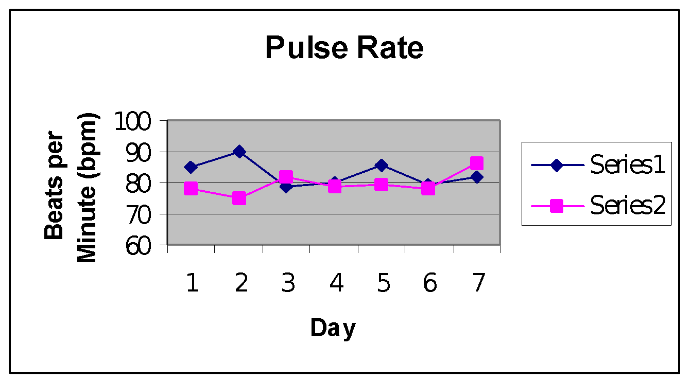

Series #1 mean: 82.9754 bpm; Series #2 mean: 79.5634 bpm

The Series #2 mean has a .056 probability of occurring by chance when compared to the Series #1 mean. This gives strong evidence that the nasal strip decreased the subject’s pulse rate.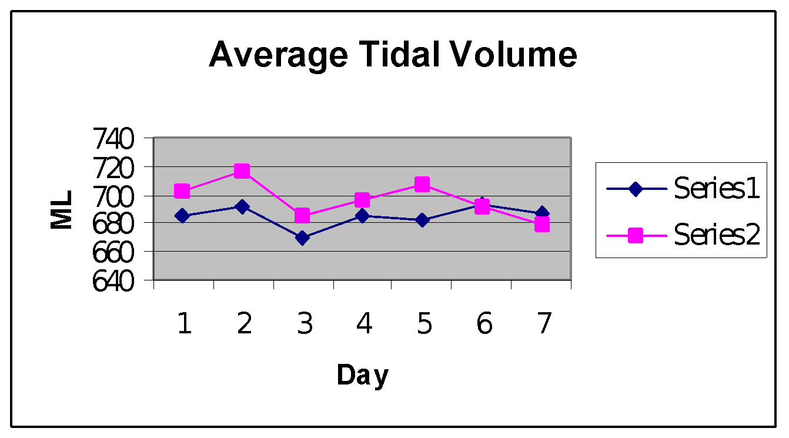

Series #1 mean: 685.019 ml; Series #2 mean: 697.1405 ml

The Series #2 mean has a .09264 probability of occurring by chance when compared to the Series #1 mean. This shows strong evidence that the nasal strip increased the subject’s tidal volume.

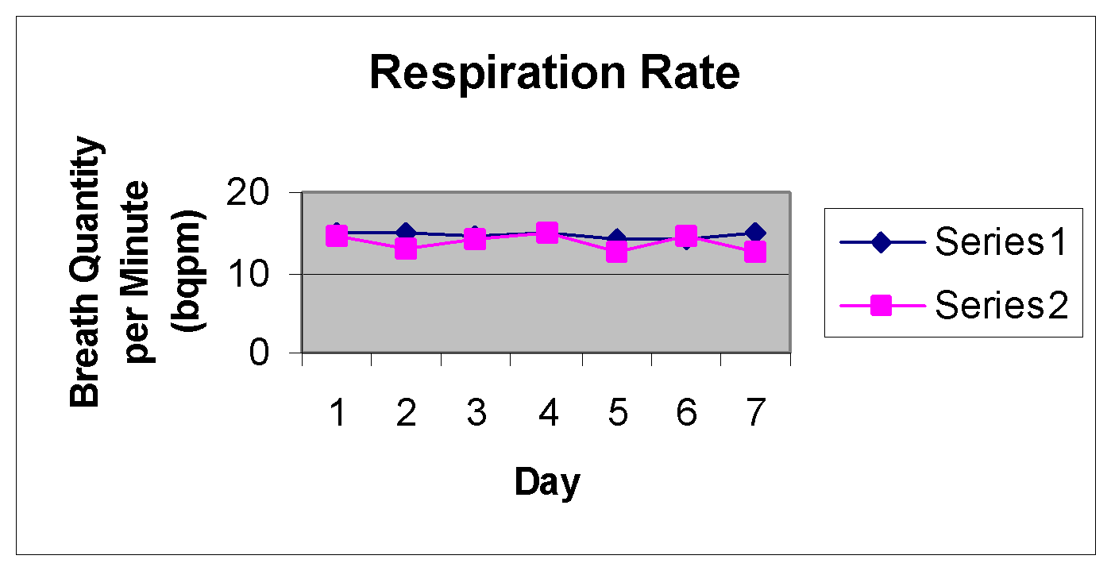

Series #1 mean: 14.82bqpm; Series #1: 13.71 bqpm

The Series # 2 mean has less than a .01 probability of occurring by chance when compared to the Series #1 mean. This shows strong evidence that the nasal strip decreased the subject’s respiratory rate.

Series #1 mean: 291,284.27 ml; Series #2 mean: 286,524.74 ml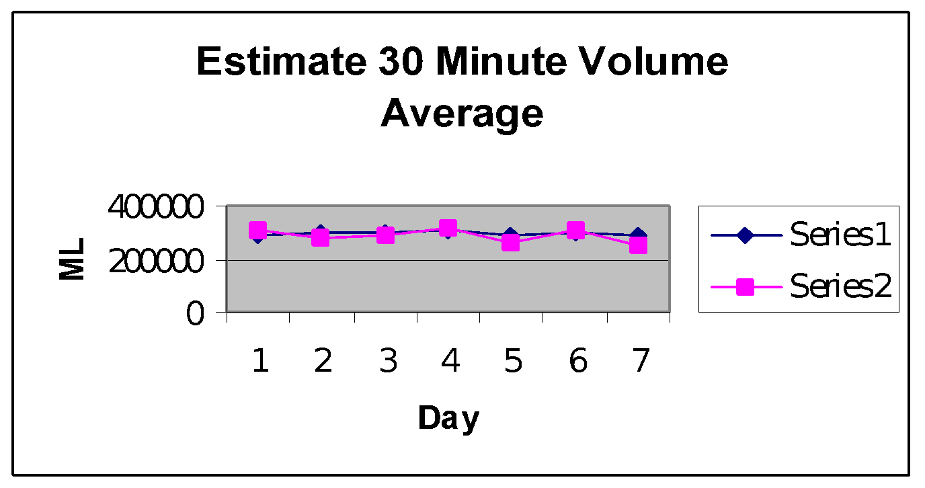

The Series #2 mean has a .8349 probability of occurring by chance when compared to the Series #1 mean. This shows weak evidence that the nasal strip either increased or decreased the subject’s 30 minute volume.